**New Results**

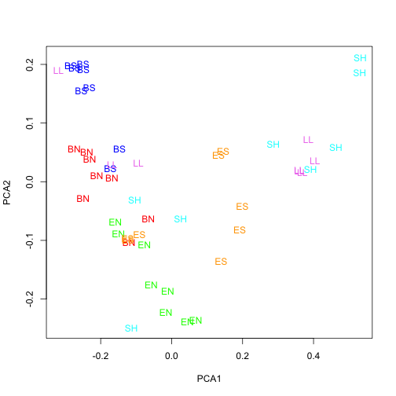

Figure 1. Principle coordinate analysis of seston fatty acid profiles. There are some pretty obvious groupings by site, and ANOSIM is significant. Not sure if this is anything of interest. May do some more analysis with this (looking at potential environmental predictors that may explain these patterns with CCA?) if we think its worth it.

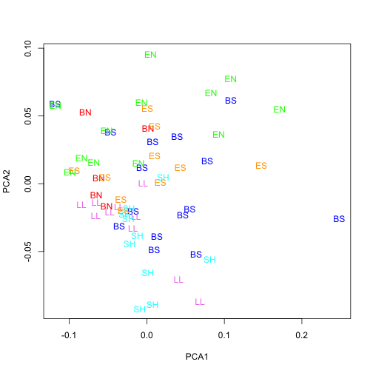Figure 2. PCA of tree swallow chick FA profiles. Not grouped very well. Makes sense as higher order consumers likely have similar FA requirements. Didn’t do one of these for bugs or boli. Bugs might have too many axes of variation if all taxa are included, boli may be interesting, but again I will do that if we think its worth it.

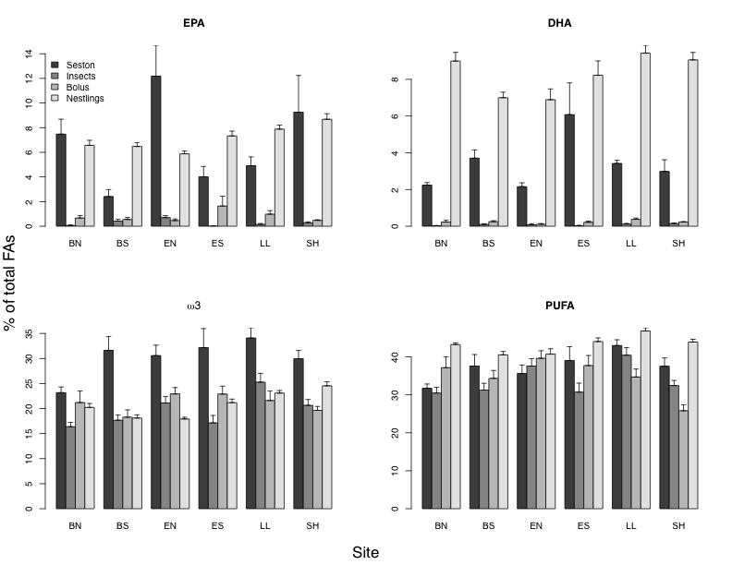

Figure 3. Trophic transfer of essential fatty acids – mainly EPA, DHA, omega 3, and PUFAs. Seston and birds enriched in EPA and DHA compared to bugs and bolus. This plot is in % of total FAs, but could also be in ug/mg DW – this way seemed best to compare across trophic levels, but doesn’t necessarily show whether or not there is less overall EPA and DHA, just that the relative proportions are smaller. Plot suggests EFAs more important for bird growth than for bugs, also birds converting shorter C-chain FAs into more important EFAs

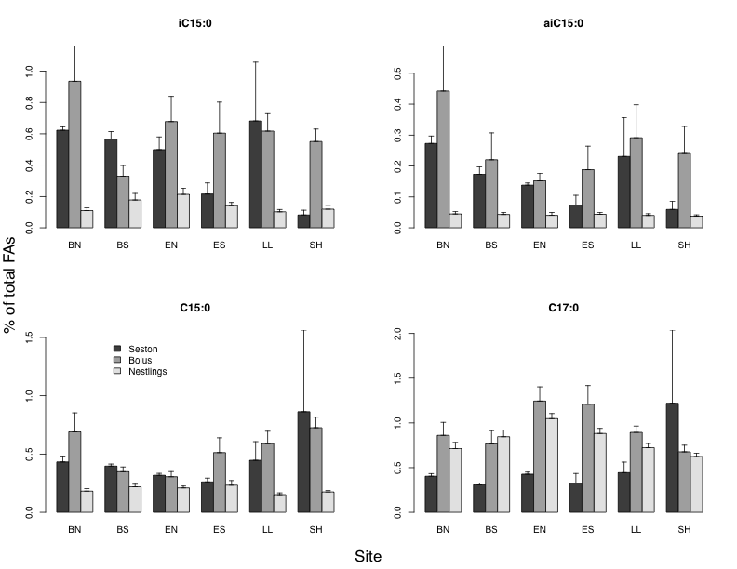Figure 4. TRophic transfer of bacterial fatty acids. Conserved in bugs (bolus – do not have these for bugs apparently), but not in birds. Must not bioaccumulate in birds, or are being converted to something else. Again, in % of total FAs, maybe putting it in ug/mg DW will tell a different story, I will look into it. Not entirely sure how this fits into the overall story yet.

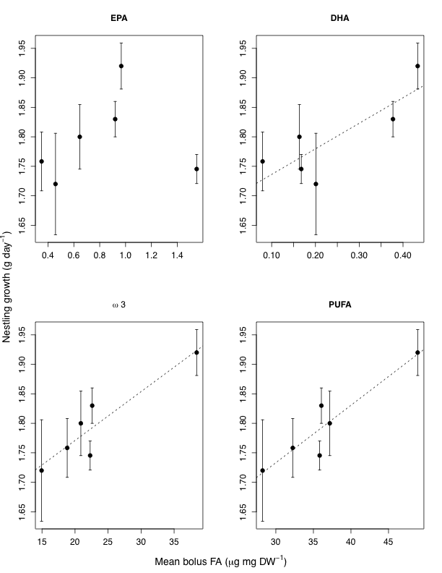

Figure 5. Chick growth vs some indices of resource quality. Appears DHA a good predictor of tree swallow growth rates. The plots with the dashed lines are significant relationships. Is this the most interesting result?

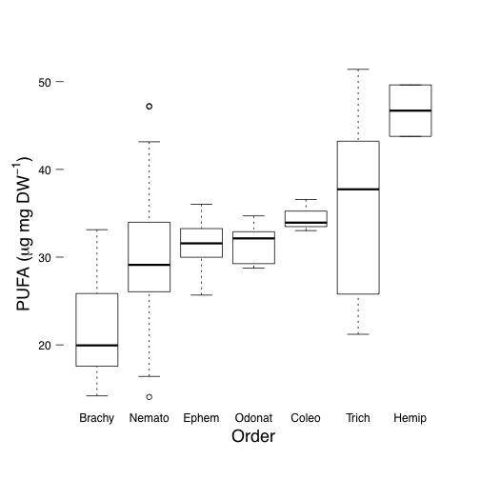

Figure 6. PUFA content of diet items. Brachycerans really low in PUFA – important in next plot.

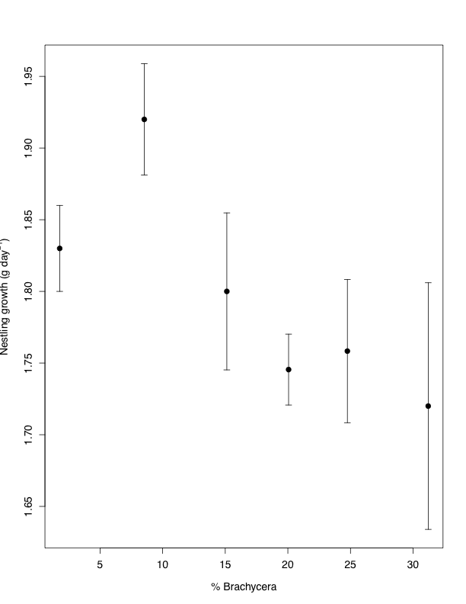

Figure 7. Average tree swallow growth rate vs percent Brachycera in the diet. Non-significant, but maybe biologically important negative relationship between the amount of low-PUFA insects in the diet and growth rate. I am going to look into whether this relationship is also true or stronger in dietary availability of Brachycera (emergence rate by site)